CLOUD COMPUTING LAB: WEEK 7

PES1201802127

Siddharth K Rao

1.) **Task 1: Setting up jenkins and using Docker**

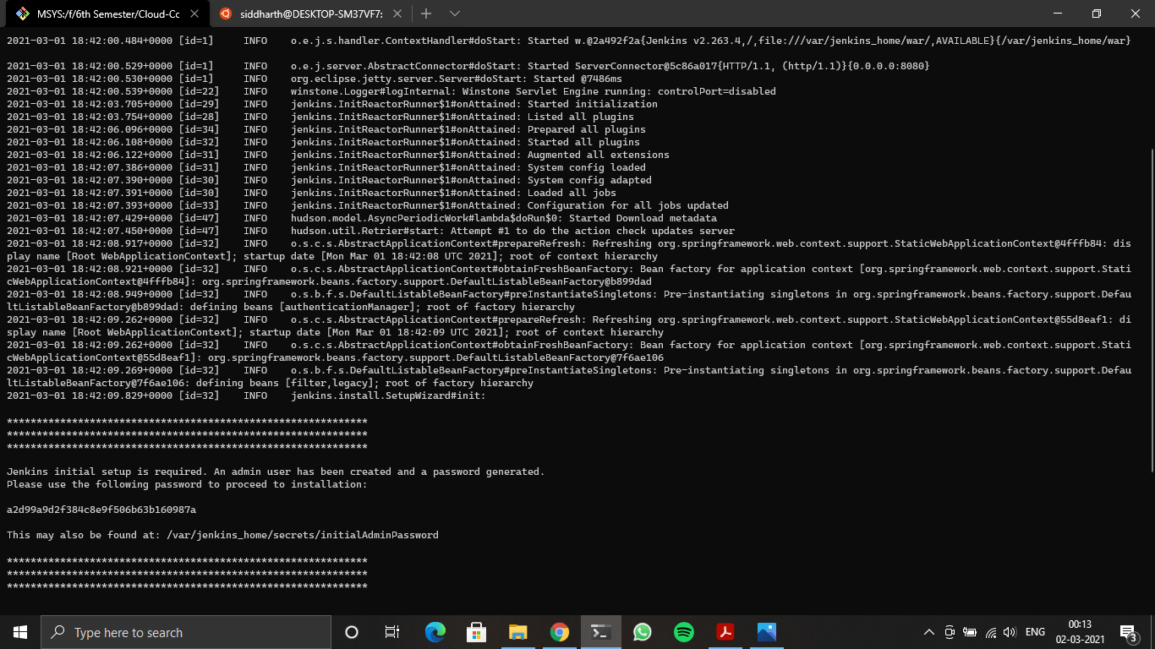

1A - Running Docker Container

2.) **Task 2: Setting up a job in jenkins to connect to a repository and build C++ hello.cpp**

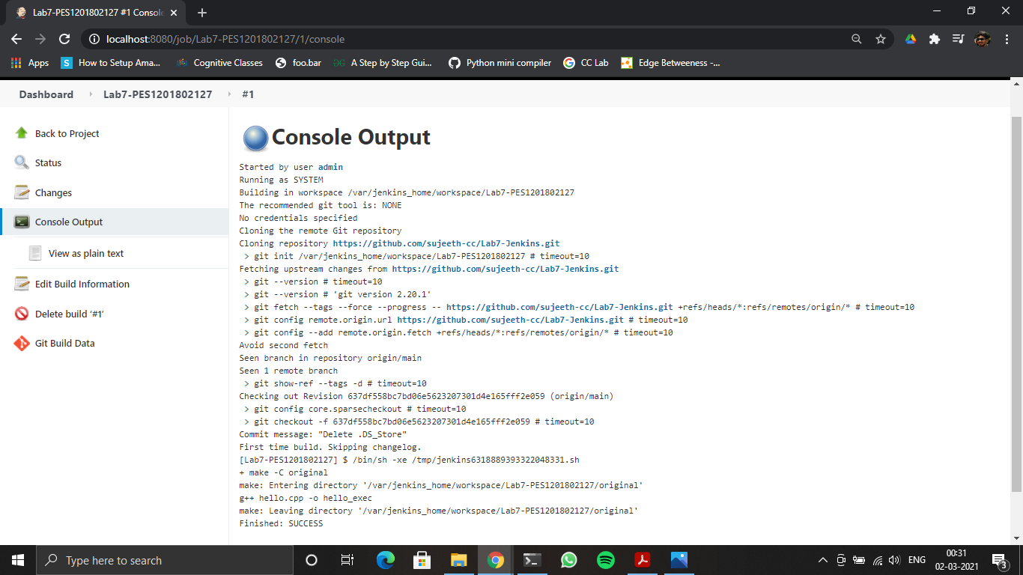2A – Console Output after the build is successful

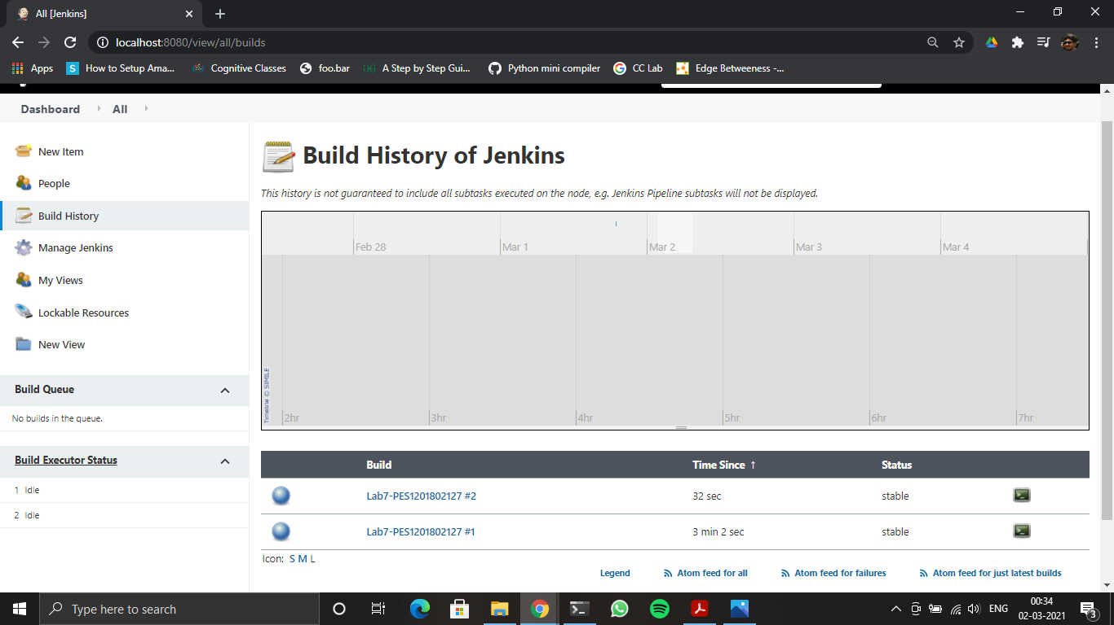

2B – Stable state of the task

3.) **Task 3:**

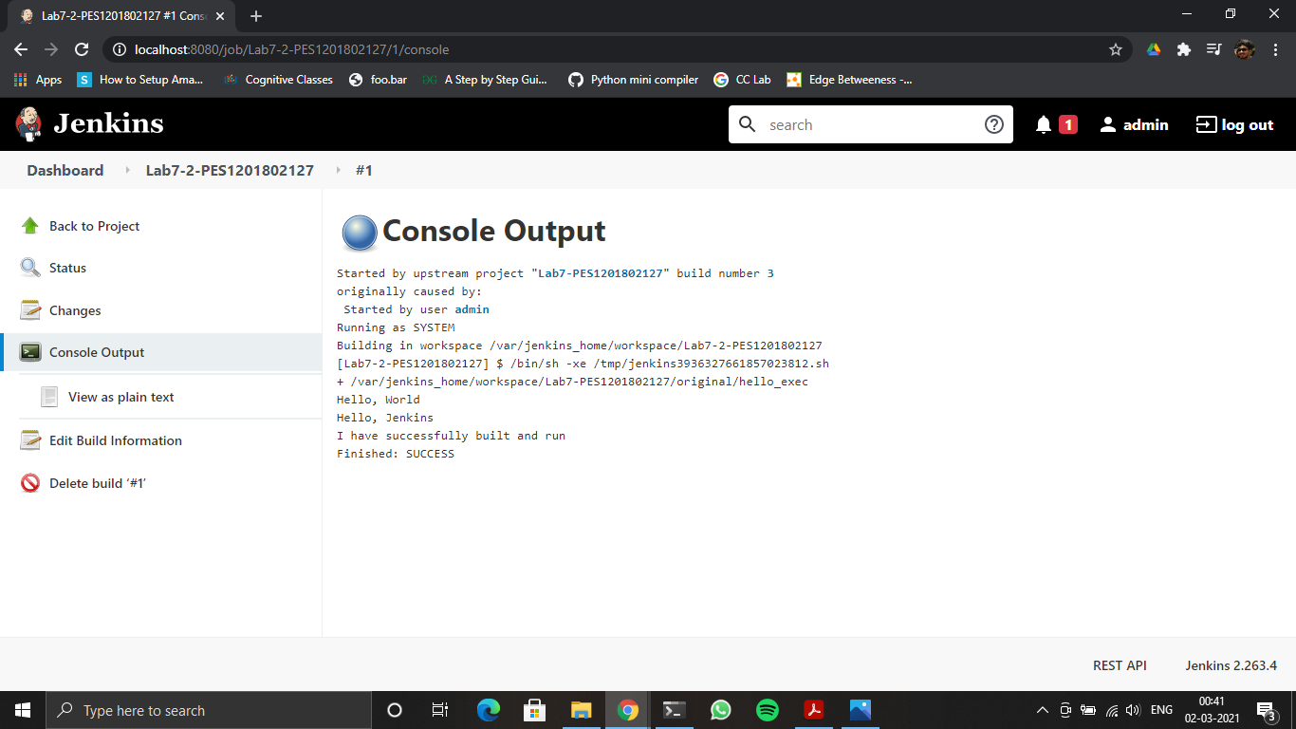

3A – Console Output of the second job

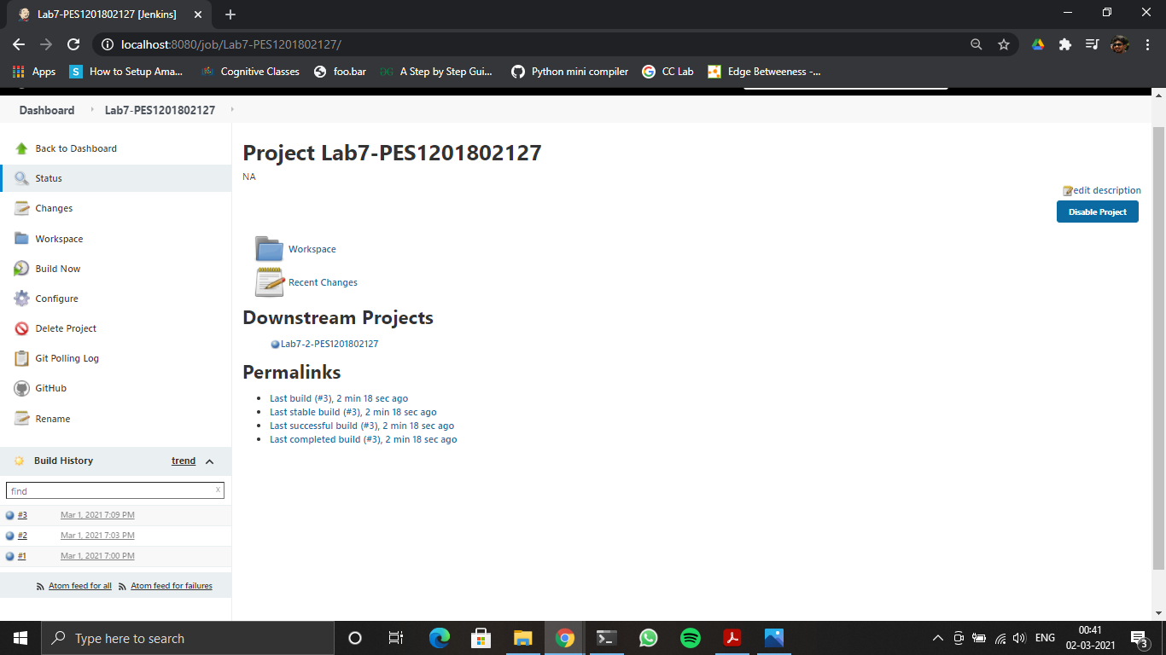

3B – Status page of the first job

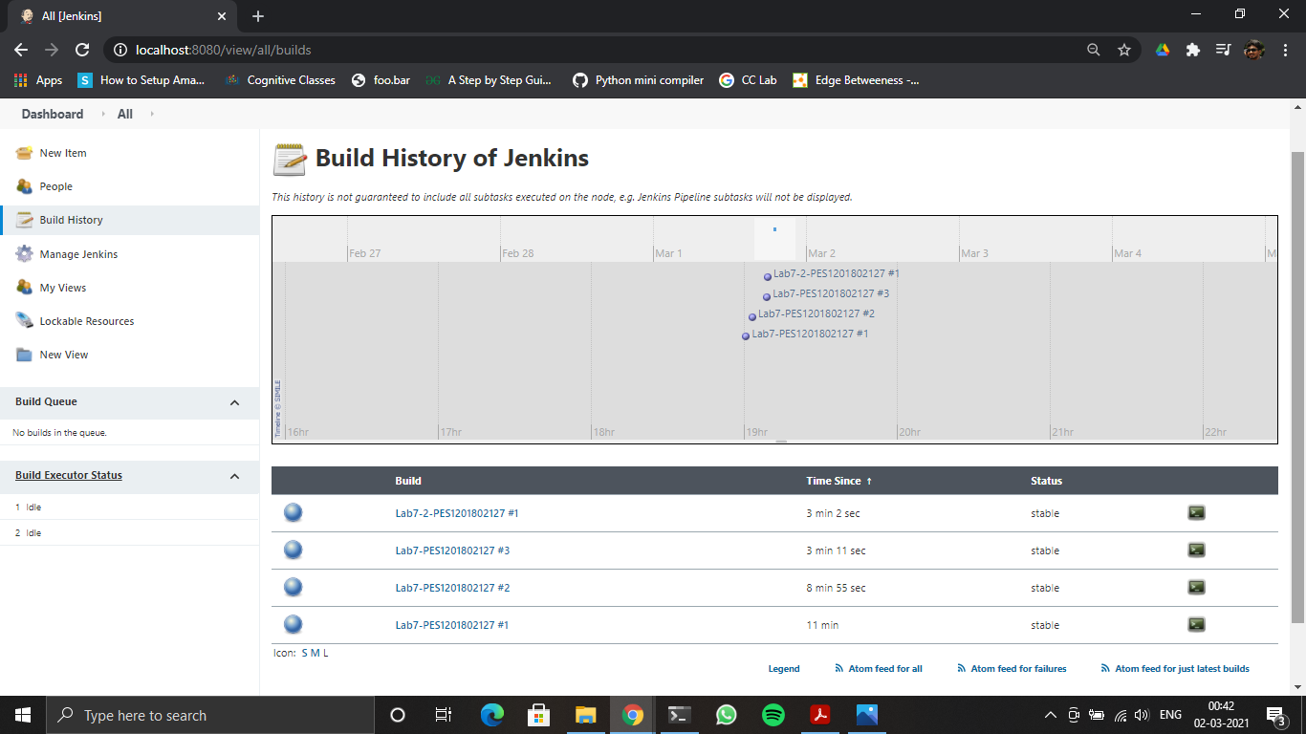

3C – Build History of Jenkins

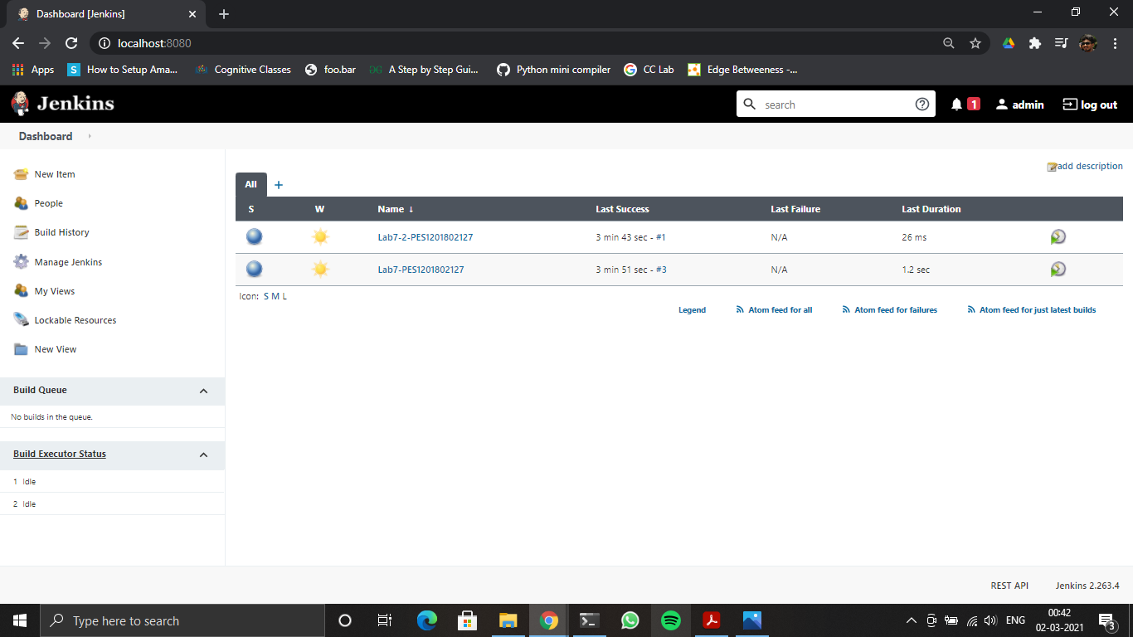

3D – Jenkins Dashboard